CS-114 - Fundamental of Programing

Lab# 9

**Course Instructor:** Dr Khwaja Fahad Iqbal

**Lab Instructor:** Muhammad Affan

## Student Name: Muhammad Hanzla Masood

**CMS ID: 463722**

**Task 1:**

#include <bits/stdc++.h>

using namespace std;

int main(){

int a[3][3], sumld=0, sumrd=0;

cout<<"Input 9 integers in the 3x3 matrix: \n";

for(int i=0; i<3; i++){

for(int j=0; j<3; j++){

cin>>a[i][j];

}

}

cout<<"The values in the matrix are: \n";

for(int i=0; i<3; i++){

cout<<"| ";

for(int j=0; j<3; j++){

cout<<a[i][j]<<" ";

}

cout<<"|"<<endl;

}

int j=2;

for(int i=0; i<3; i++){

sumld+=a[i][i];

sumrd+=a[j][i];

j--;

}

cout<<"Sum of left diagonal: "<<sumld<<endl

<<"Sum of right diagonal: "<<sumrd<<endl;

return 0;

}

**Task 1 Output:**

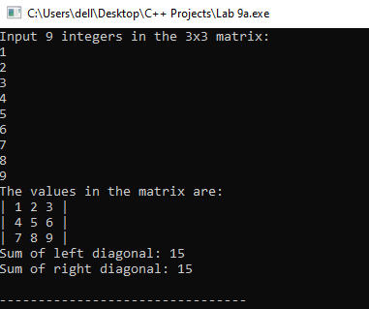

**Task 2:**

#include <iostream>

using namespace std;

int main(){

int a[3][3], b[3][3], sum[3][3];

cout<<"Input 9 integers in the 3x3 matrix: \n";

for(int i=0; i<3; i++){

for(int j=0; j<3; j++){

cin>>a[i][j];

}

}

cout<<"Input 9 integers in the second 3x3 matrix: \n";

for(int i=0; i<3; i++){

for(int j=0; j<3; j++){

cin>>b[i][j];

}

}

cout<<"The values in the matrix are: \n";

for(int i=0; i<3; i++){

cout<<"| ";

for(int j=0; j<3; j++){

cout<<a[i][j]<<" ";

}

cout<<"|\t| ";

for(int k=0; k<3; k++){

cout<<b[i][k]<<" ";

}

cout<<"|"<<endl;

}

for(int i=0; i<3; i++){

for(int j=0; j<3; j++){

sum[i][j]=a[i][j]+b[i][j];

}

}

cout<<"The sum of the two matrix is: \n";

for(int i=0; i<3; i++){

cout<<"| ";

for(int j=0; j<3;j++){

cout<<sum[i][j]<<" ";

}

cout<<"|"<<endl;

}

return 0;

}

**Task 2 Output:**

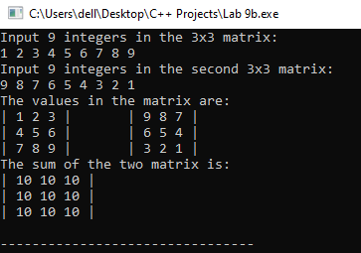

**Task 3:**

#include <iostream>

using namespace std;

int transpose(int a[3][3]){

int temp=0;

for(int i=0; i<3; i++){

for(int j=i+1; j<3; j++){

temp=a[i][j];

a[i][j]=a[j][i];

a[j][i]=temp;

}

}

}

int main(){

int a[3][3];

cout<<"Input 9 integers in the 3x3 matrix: \n";

for(int i=0; i<3; i++){

for(int j=0; j<3; j++){

cin>>a[i][j];

}

}

cout<<"The values in the matrix are: \n";

for(int i=0; i<3; i++){

cout<<"| ";

for(int j=0; j<3; j++){

cout<<a[i][j]<<" ";

}

cout<<"|"<<endl;

}

cout<<"The transpose of the matrix is: \n";

transpose(a);

for(int i=0; i<3; i++){

cout<<"| ";

for(int j=0; j<3; j++){

cout<<a[i][j]<<" ";

}

cout<<"|"<<endl;

}

}

**Task 3 Output:**

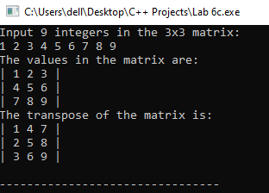

**Task 4:**

#include <bits/stdc++.h>

using namespace std;

int multiply(int a[3][3], int b[3][3], int ans[3][3]){

for(int i=0; i<3; i++){

for(int j=0; j<3; j++){

for(int k=0; k<3; k++){

ans[i][j]+=a[i][k]*b[k][j];

}

}

}

}

int main(){

int a[3][3], b[3][3], ans[3][3]={{0},{0}};

cout<<"Input 9 integers in the 3x3 matrix: \n";

for(int i=0; i<3; i++){

for(int j=0; j<3; j++){

cin>>a[i][j];

}

}

cout<<"Input 9 integers in the second 3x3 matrix: \n";

for(int i=0; i<3; i++){

for(int j=0; j<3; j++){

cin>>b[i][j];

}

}

cout<<"The values in the matrix are: \n";

for(int i=0; i<3; i++){

cout<<"| ";

for(int j=0; j<3; j++){

cout<<a[i][j]<<" ";

}

cout<<"|\t| ";

for(int k=0; k<3; k++){

cout<<b[i][k]<<" ";

}

cout<<"|"<<endl;

}

multiply(a, b, ans);

cout<<"The product of the two matrix is: \n";

for(int i=0; i<3; i++){

cout<<"| ";

for(int j=0; j<3; j++){

cout<<ans[i][j]<<" ";

}

cout<<"|"<<endl;

}

return 0;

}

**Task 4 Output:**

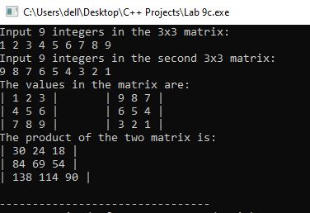

**Task 5:**

#include <iostream>

using namespace std;

int table(int fnum, int temp=1){

if(temp==11){

return 0;

}

cout<<temp<<"*"<<fnum<<"="<<temp*fnum<<endl;

return table(fnum, temp+1);

}

int main(){

int fnum, product;

cout<<"Input an Integer: ";

cin>>fnum;

cout<<"The table of "<<fnum<<" is: \n";

table(fnum);

return 0;

}

**Task 5 Output:**

